Applied Skills Training on Robotics @ TP HRG
Name & Matrix Number: Darren Ong Yan En (2004217B)
Date and Time: 3 December 3-5pm
1 snapshot of you going through robotics training (2 marks)
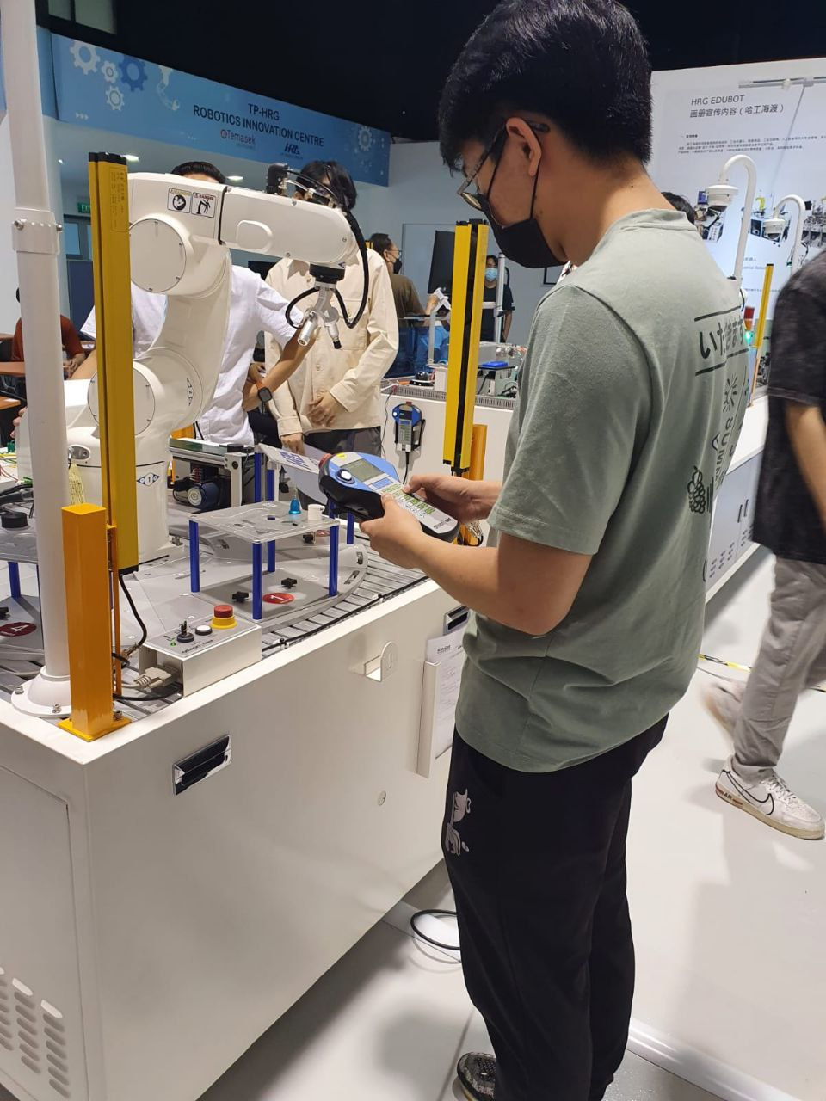

2 Learning points you have acquired (4 marks)
Robotics are customizable from its components, configuration and operations. Theses include robots arms, smart vision, servo system, RFID, PLC, feeding units, pressing units and transport mechanisms.

The PLC(Programmable Logic Controller) Control System in robotics are the “bosses” which control most processes. They receive information from sensors, inputs and process it to trigger varying outputs.

Reflection on human-robotics collaboration in modern workplace (4 marks)
The integration of humans and robotics are essential due to their varying benefits. Humans offers cognitive skillsets and flexibility that robotics are not able to provide yet. However, humans are not perfect. Robotics are able to cover this weakness by working tirelessly, with accurate precision.

In a modern workplace, it is transparent that robotics will take over any work that requires hard labour such as assembling which can be automated. This does not mean that robots are “taking over” human jobs as there will still be a need for engineers to collaborate with the robots.

Robot Controllers and teach pendants are imperative for human robotics collaboration. Robotics should always come with suitable safety features and functions for the protection of humans such as safety light curtains which automatically halt the machine if humans(or external objects) are detected within the operations of the robot while it is jogging. With processes such as wielding, force control, and assembly, robotics can help a modern workplace save both manpower and costs.

